## Flow in Microsoft Dynamics 365 | Power Automate

### Automatic Purchase Order Approval and Vendor Notification

**Scenario:** A company uses Microsoft Dynamics 365 Business Central (BC) to manage purchasing.  
Whenever a Purchase Order (PO) is created and exceeds a certain amount (say $10,000), we want to:

1. Automatically send an approval request to the purchasing manager.
2. Once approved, update the PO status in Business Central.

This flow shows:

* Integration between Power Automate and Business Central
* Conditional logic and approvals
* Real-world business impact

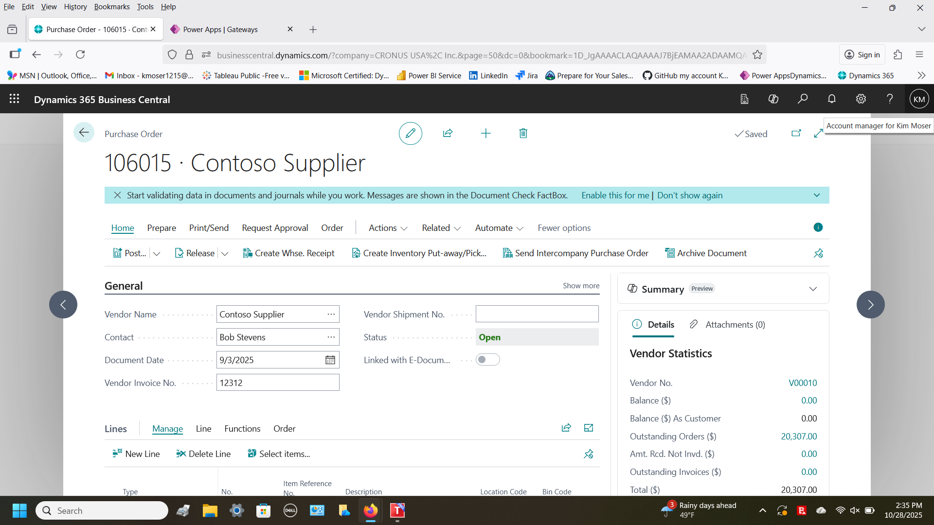

PO # 106015 created for Contoso Supplier in the amount of $ 20,307 (>10,000) in Dynamics 365 Business Central is our trigger to start the approval flow)

Building flow in Power Automate

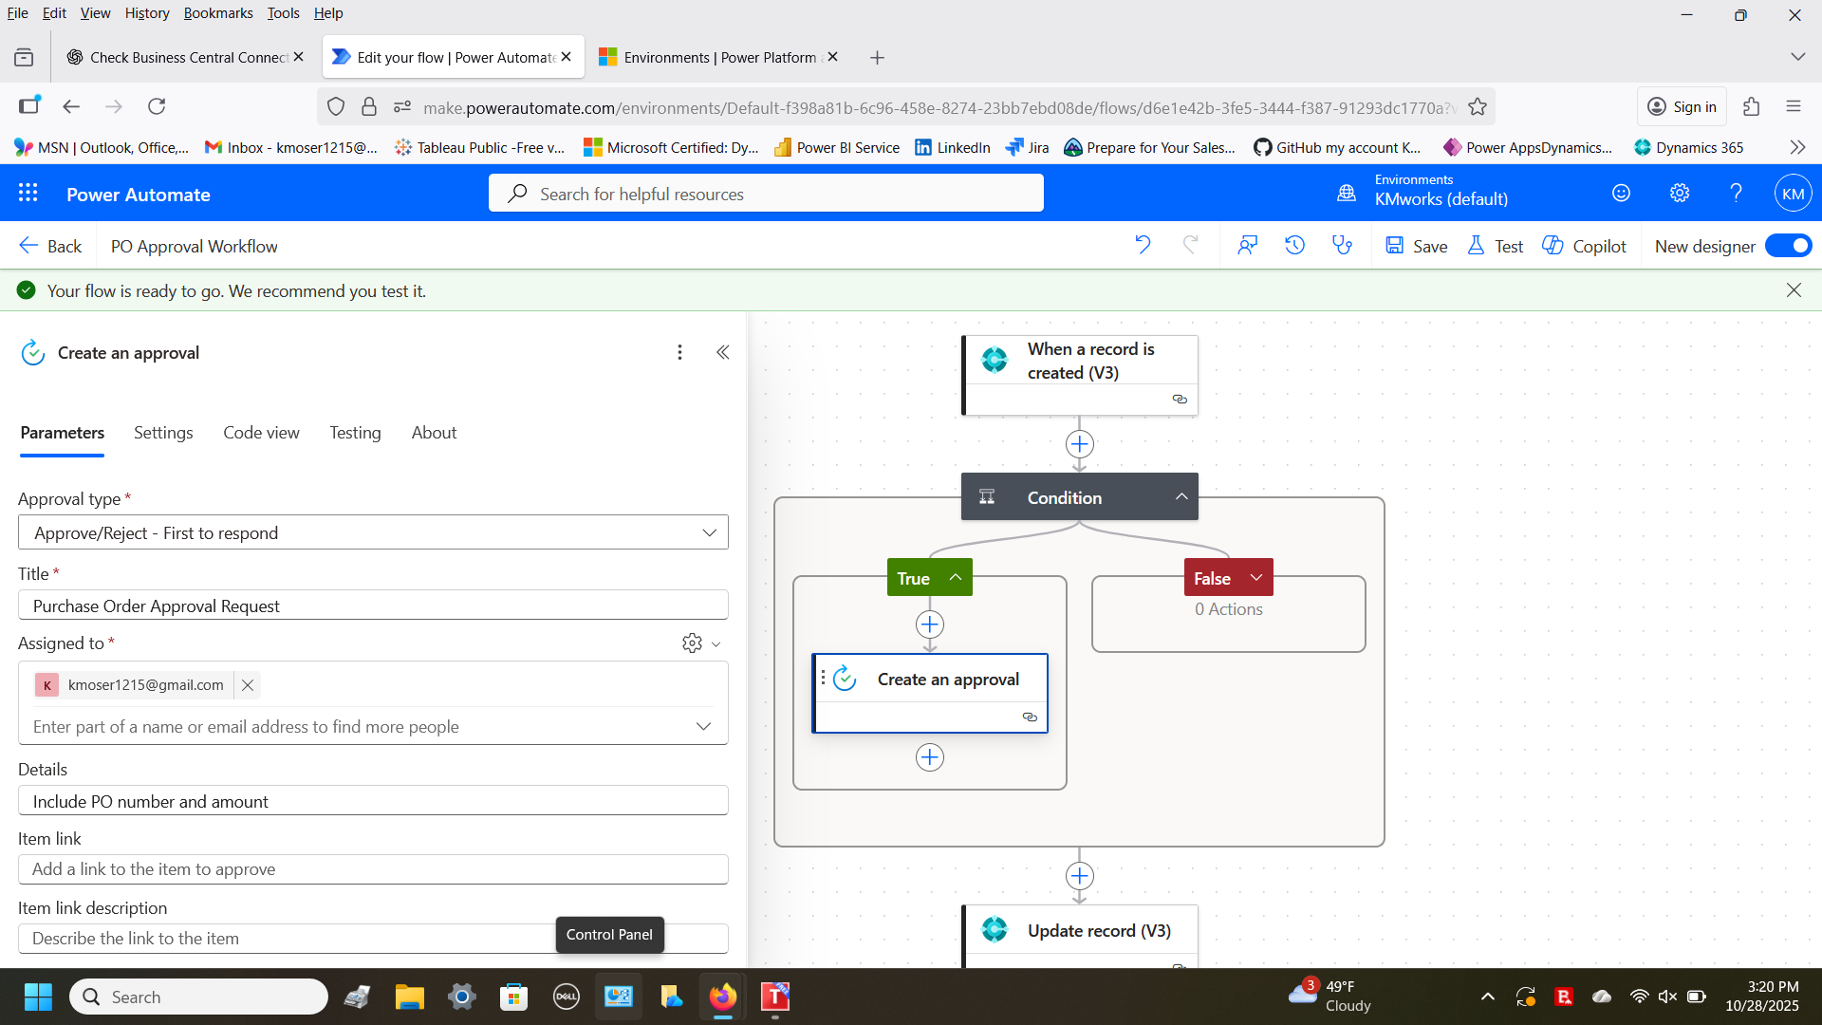

Flow setup to create an approval request when a PO is created over $10,000 and email approver [kmoser1215@gmail.com](mailto:kmoser1215@gmail.com) to approve and update the status from open to released.

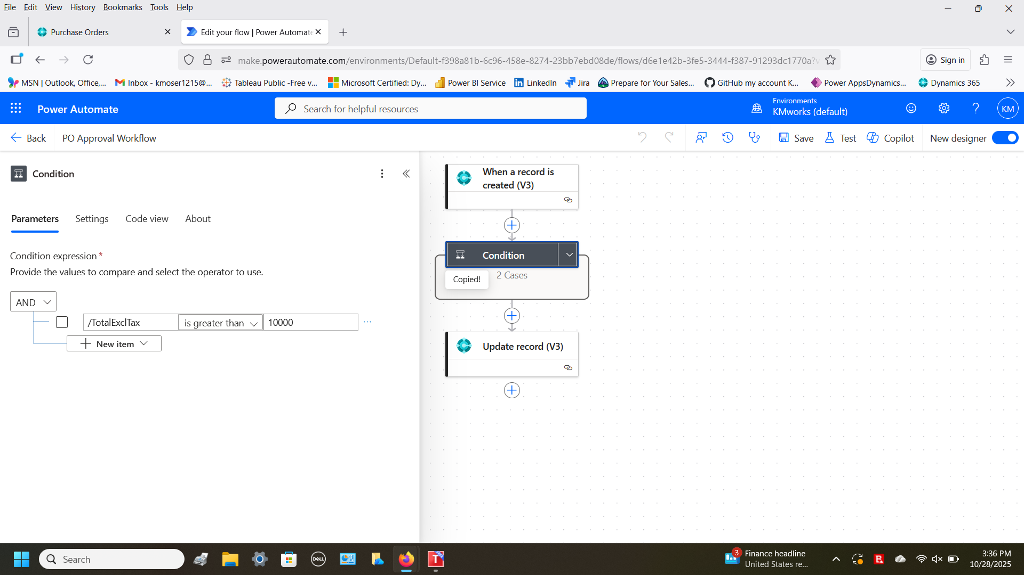

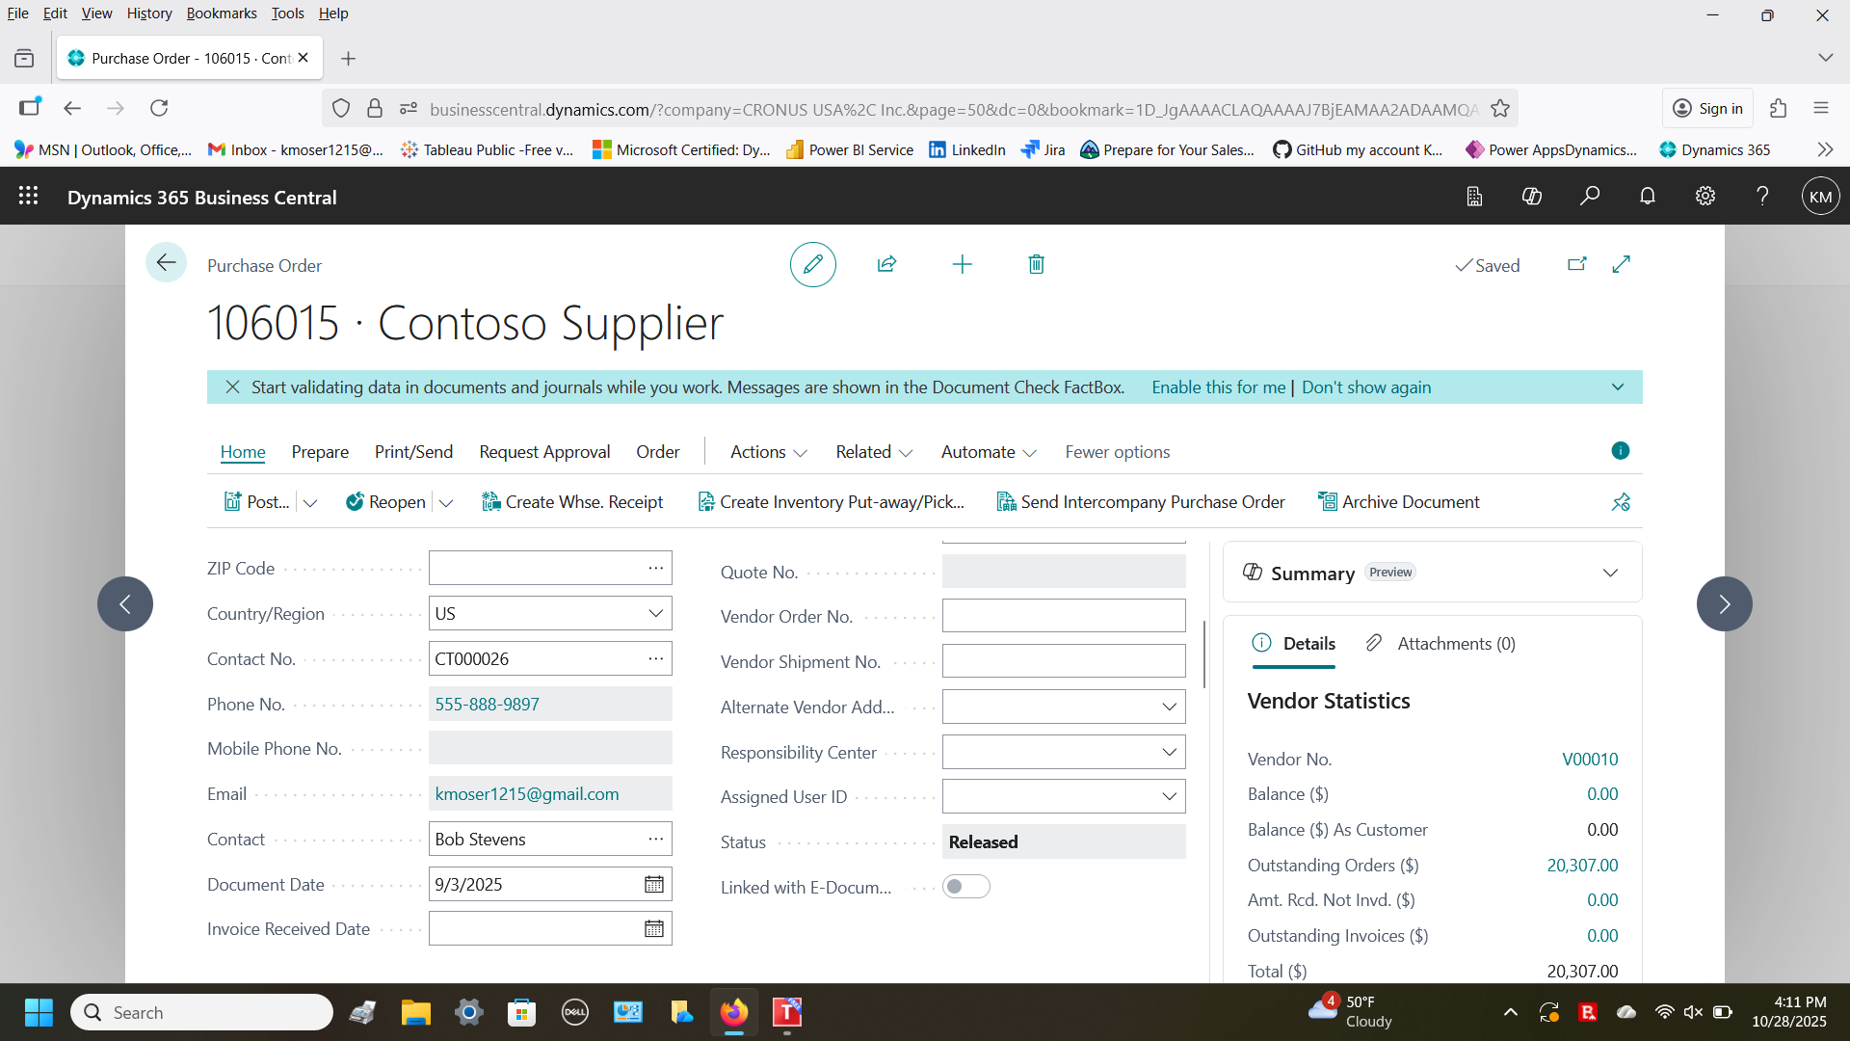

PO approved and status updated to released